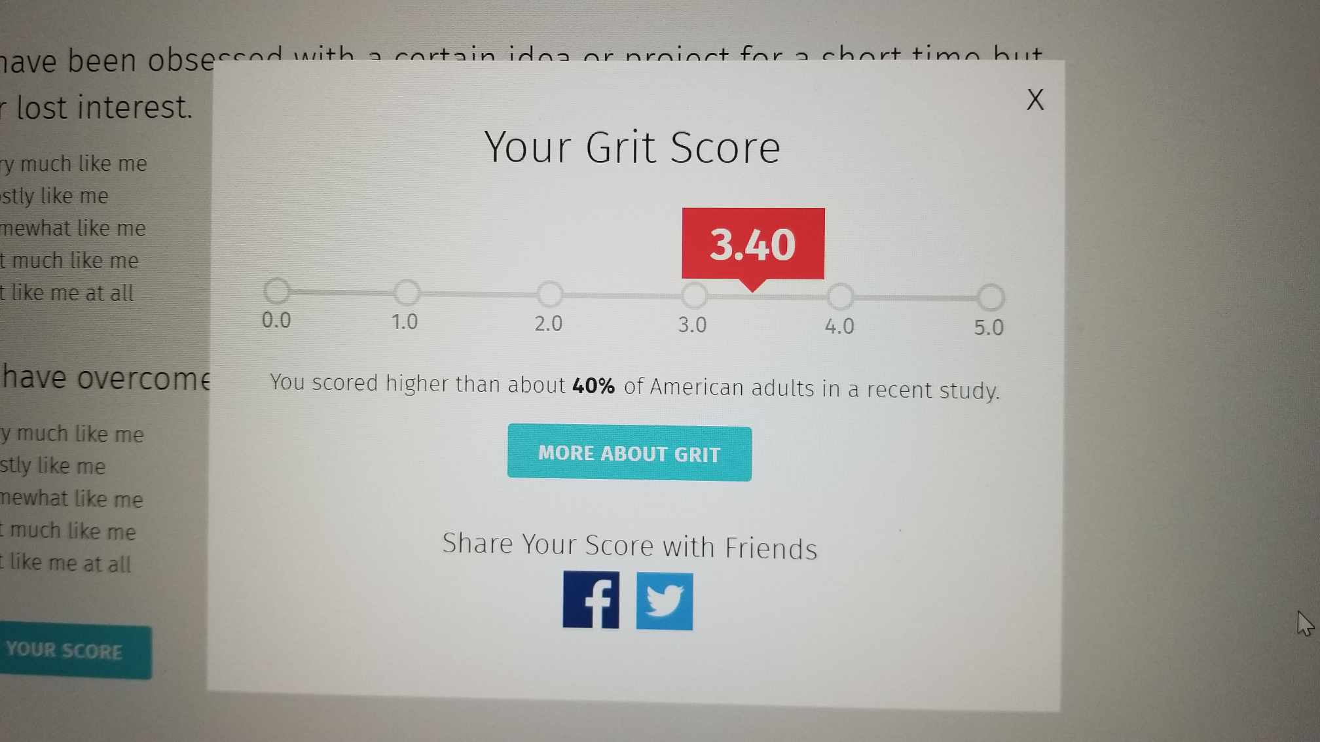
I feel this is accurate, and I didn't find any surprises. I am glad we are speaking on grit, as it is a word I had lost track of, relevant in several aspects in my life.

